Forrest Gump

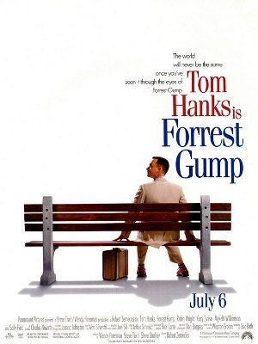
Forrest Gump is a man with an IQ of only 75. In the film, he sits on a bench, waiting for the bus which should bring him to Jenny, his best friend and only one love since they’ve met in the school bus for the first time.
While he’s waiting, he tells a whole lot of people about his life. Almost everything he did was coincidence. With an age of six or seven years, he gave Elvis Presley the idea for his legendary pelvic thrust. He became a popular football star, went to the United States Army, met three presidents (John F. Kennedy, Lyndon B. Johnson and Richard Nixon), detected accidentally the Watergate-Affair and opened – because he promised it Bubba, his friend in the Vietnam War – the “Bubba Gump Shrimp Company”, through which he got rich. In all the years he experienced so much, Jenny appeared again and again, but she never stayed for a long time.
The last thing Forrest tells an old woman is the story about his three-year-enduring run through Northern America. After that, he goes to Jenny’s apartment where he meets his four-year-old son Forrest Junior for the first time. They stay together for a while and Jenny narrates that she has an incurable disease. But that doesn’t matter to Forrest and a little bit later they marry. When Jenny dies shortly after that, Forrest is devastated, but he contends with it and carries lovingly about his son.

coincidence = Zufall
pelvic thrust = Hüftschwung
to narrate = erzählen
incurable disease = unheilbare Krankeit
devastated = am Boden zerstört

Additional information:

The film is about a man’s life and love.
It’s from 1994 with the main characters Tom Hanks, Robin Wright and Sally Field.
The movie got six Oscars, for example for “best actor” and “best direction”.

Most interesting citations of Forrest:

“Life is like a box of chocolate, you never know what you’re going to get.”
“Stupid is who stupid does.”
“Maybe I’m not a smart man, but I know what love is!”

